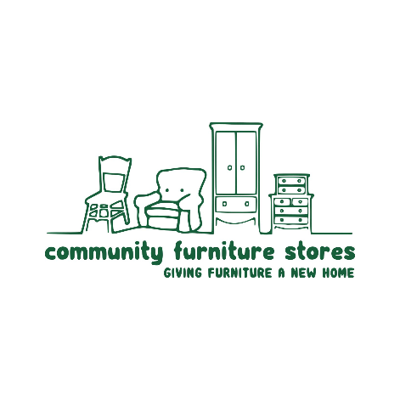

CFS Reuse Guidance
June 2026

This guide outlines what items our stores accept and the processes we follow to ensure that we are meeting legal requirements, operating safely and providing the best possible service to our customers.
All items donated to us must be in good, clean and saleable condition, free from any rips, tears, stains, marks or damage. Our drivers make the final decision about whether or not we can accept an item. We will try to accept as many items as possible but we may have to decline certain items due to stock levels in our limited space.
The items that are accepted may depend on the store and at times may vary slightly from the list below. Please note, we are not able to clean items that have been used by animals or which smell of smoke and are therefore not able to accept them.
Please be kind and respectful of decisions made by our teams who are simply following organisational guidance.
Overview
Items we do take | Items we don’t take
- Sofas, armchairs, footstools, conservatory furniture  - Beds and mattresses (including electric beds)  - Dining tables and chairs  - Wardrobes, chest of drawers, dressing tables  - Coffee tables, side boards, nest of tables  - Dressers, display cabinets  - Mirrors, pictures, paintings  - Desks, shelving, office chairs and furniture  - White goods, TVs and electrical items  - Mobility aids (wheelchairs, walkers, zimmer frames)  - Computers (see guidelines here)  - Unopened, full tins of paint  - Garden furniture  - Rugs and curtains | - Upholstered items that don’t have a fire label  - Non-UK fire labels  - Children’s items e.g. prams, cots, toddler beds  - Large items of furniture which cannot be disassembled  - Mobility scooters  - Bikes  - Toys and games  - Duvets and beddings  - Toilets and commodes  - Integrated white goods  - Hardwired electricals e.g. pendant light fittings  - Knives and sharp items e.g. saws  - Cleaning supplies/chemicals  - Power tools with blades  - Wall units that are over 4 foot wide

Fire labels
What is a fire safety label?
Permanent fire safety labels are legally required on upholstered items and furnishing such as a sofa to let people know that the item complies with British Furniture and Furnishings Fire Safety Regulations.
Many upholstered items contain foams, fillings and other materials that could potentially be flammable and therefore must have set levels of fire resistance determined through a series of flammability tests.
Fire regulations state that:
- The fillings inside materials must meet ignition requirements
- Upholstery and covers must be cigarette and match resistant
- A permanent label must be fitted to every new item of furniture
- A display label must be fitted to every new furniture item at the point of sale
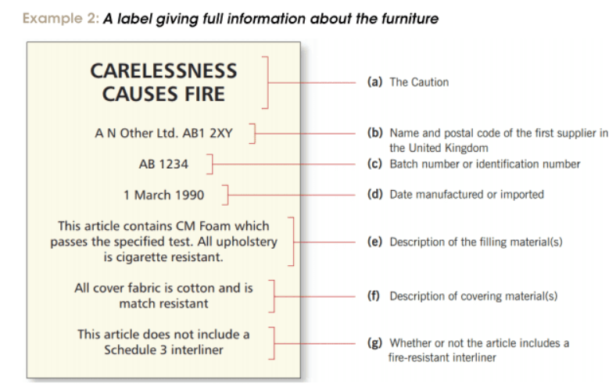
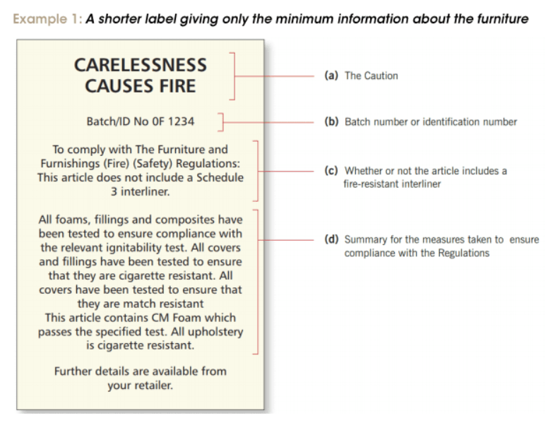
What does a fire label look like?

It can typically be found sewn in under a cushion or on the edges of an item. Sometimes the labels can also be found underneath the item too.
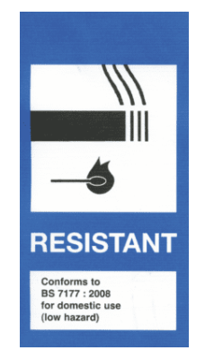
Sofa beds need two fire labels, one on the mattress and one on the sofa. The one on the sofa is often inside the carcass of the sofa.
Mattresses, divans and bed bases
The fire labels for mattresses, divans and bed bases are covered by a separate piece of legislation – BS 7177. They typically look like the following label.
The label on mattresses and upholstered bed bases are usually sewn in and located at the bottom of the item. Bed bases without foam i.e. a divan bed base made out of wood but covered in material, does not require a fire label.
Other items which require a fire label:
- Ottomans
- Telephone tables with cushions
- Footstools
- Bean bags
- Cushions & pillows
- Upholstered headboards
Items that are exempt from fire labels:
- Office chairs providing they have 5 star shaped legs
- Items upholstered using horsehair rather than synthetic materials
- Antique furniture (an item that can be proven to be from before 1950)
- Non-upholstered bed bases or divan bases without foam
Key points:
- It is against the law to sell an upholstered item if it doesn’t have a permanent fire label attached
- If an item is sold as part of a set, there must be a fire label present on every item
- All fire labels should contain ideally have a batch number
Glass
- Glass tabletops should have a thickness of at least ½ inch (1.3cm)
- We cannot accept any items with damaged glass on them. This includes chips or cracks.
Electricals
Items that have a plug fall under the category of electricals. All items will be PAT and function tested before sale.
CE marks

It is a requirement that all electrical equipment for sale has a CE mark, or from Jan 2021 a UKCA mark (post Brexit), to confirm the product meets UK/EU legislation. Electrical Items without a CE approval mark are now over 35 years old and manufactured to out-of-date specifications, technologies and materials that will have deteriorated e.g. any rubber or flexible cable will be degraded, and plastic brittle.
Any items of furniture with inbuilt lighting that does not have a CE or UKCA mark, can still be sold but the plug and wires must be cut.
Electrical checks
The below checks need to be completed, before accepting electrical items:
- No exposed wires
- No rust
- All seals intact
- Light bulbs removed
White goods
All white goods must be in a clean, good and saleable condition. On arrival, all white goods will be PAT tested by the drivers before accepting the item.
Fridges and freezers
Before the item is collected, the customer will be asked to:
- Empty and clean fridge
- Leave on for 24 hours prior to collection
- Defrost freezer
Cookers
We cannot accept gas cookers. Electrical cookers in good, clean condition might be accepted depending on the store.
Washing machines
We cannot accept washing machines with a hot and cold feed.
Electric beds
All electric beds must have metal stopper on the side of the beds and need to be complete with mattress. Unfortunately, if the mattress is unclean, we cannot accept the mattress nor the base.
Hard wired electricals
There are some items which we cannot test and therefore cannot accept. These include:
- Pendant light fittings
- Integrated white goods
- Electric fires and heaters
Electrical tools
We can take power tools providing they don’t have blades.
Repairs
We can only accept items that are in a good and saleable condition. Generally, we are not in a position to repair items. We will do our best to reduce waste where possible and undertake minor repairs but it’s at the store’s discretion whether or not they have the capacity and skills at the time.
Checklists
Bunk beds
We can accept bunkbeds providing that they meet the below requirements, please see Children’s Reuse Items Checklist for more information.
- A recommended height to the upper surface of the bed base of 400mm
- No gaps anywhere that are less than 60mm or more than 75mm
- The gap that allows access to the top bunk must be in the safety barrier on one of the long sides of the bed and needs to be a minimum width of 300mm
- Guard rails need to be in place on each side on the top bunk
- The ladder needs to have treads at least 3cm wide and 20cm apart
- If the ladder has circular rungs then these are allowed
- The gaps between the slats underneath the mattress needs to be no less than 7.5cm
- The mattress needs to be at least 10cm below the top of the guard rail and needs to fit snugly and securely
Walking aids and wheelchairs
Walking aids must meet the below requirements, please see Walking Aid Checklist for more information.
- Evidence of CE OR UKCA mark
- Evidence of BS EN 1986:1999 / BS EN ISO 11199 mark
- Item is free from wear and tear and in good condition
Wheelchairs must meet the below requirements, please see Wheelchair Checklist for more information.
- Evidence of BS ISO 15042-1 mark
- Evidence of CE OR UKCA mark
- The seat must be secured to the chair frame
- Item is free from wear and tear and in good condition
We cannot accept items with a Mediquip barcode, they need to be returned directly to Mediquip.
IT ReUse
IT ReUse is a project based in our York store which repairs, refurbishes and redistributes IT equipment to people at risk of financial inclusion. We are reliant on donations from the public to provide this service.
We accept the following donations:
- Laptops manufactured after 2012
- Smartphones manufactured after 2016
- Tablets manufactured after 2018
- Desktop PCs manufactured after 2017
- We are now partnered with a reputable e-waste company which allows us to recycle all electronics
- Computer monitors with screens that are in good condition
All smartphones and tablets need to be factory reset before they can be donated to us. More information can be found on our website.

